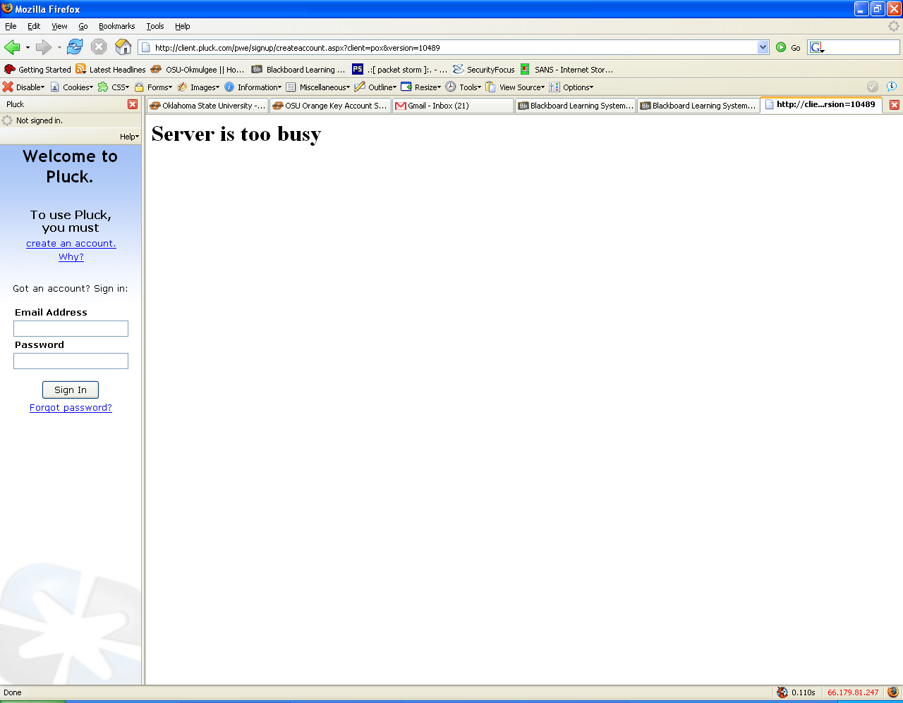

Pluck is an RSS feed reader. SecurityFocus is an RSS feed having to deal with security. We couldn’t get very far with Pluck due to the fact the server is too busy. I’m assuming SecurityFocus has a lot of useful information having to with security. And I guess that I could probably subscribe to the feed in IE and Firefox if it were working. The book makes SecurityFocus sound like it rules. I’ll take its word for it too.

